Visit Report: Barguna Sadar Hospital, Barguna.
Date of Visit: 23/08/22; Time: 10:45 AM.
Visitor: Md. Abdul Hakim Mazumdar, National Consultant (HEU),
Dr. Md. Emdadul Haque, National Consultant (HEU)
Md. Shamsur Rahman, Junior National Consultant (HEU) &
Dr. Nazmur Rahman Sajib, Junior National Consultant (HEU)

1. We arrived at 10:45 am in the hospital. Superintendent, RMO, consultants were present. We discussed with them about the overall situation of the hospital. We also discussed with them about the SSK program and role of the District Hospital in SSK.
2. There are 10 post of senior consultants but all post is vacant. Out of 11 post of junior consultant, 7 post is vacant. Only Surgery, Gynae, Anesthesiology and Orthopedics junior consultants are available.
3. There are two cleaners. One cleaner posted in the hospital; another one is from deputation. There is no Aya, ward boy, guard, gardener, electrician and trolley-man. 12 cleaners are supported from the Powroshova. 20 post of outsourcing is created, but only 11 post is approved in recruitment policy. Till now, no one is appointed for work.
4. The infra-structure of this hospital is 100 bedded. The physical condition of the hospital building is satisfactory. There is another 150 bedded infra-structure building available within the hospital campus. There is an administrative approval in 20-10-20 to start as 250 bedded hospital. Drugs, MSR and Diet supply is necessary and the post of 250 bedded human resources are yet not created. Its is under the process in health ministry.

5. We visited outdoor of the hospital which was crowded with patients. We also observed Emergency, pathology and pharmacy department. The automation of indoor and outdoor is functioning. The information display system was satisfactory but not updated. There was no effective health education system.
5. Cleanliness of the hospital premises and indoor was poor. There are separate operation theatres for performing major operations.
6. There is a small cycle stand close to the main gate. There are many motorcycles parked within the premises.
7. The roof of the hospital was clean and beautiful.
8. There are spaces for SSK Booth and Pharmacy close to the emergency department.
9. There are many “Danbox” throughout the hospital.
10. There is no conference room in the old building but using a room in new building as conference room.
11. There is no facility for caesarean section 24/7.
11. In 2021, total OPD patient was 1,21,486. Indoor admitted patient was 18,613. Bed occupancy rate was 141.8%. Total ANC visit in 2021 was 661. Total delivery was 1101. Among them NVD was 466, C-section was 83.

Human Resources of 100 Bedded Hospital:
Sl. | Designation | No. of Post | Present | Vacant
1. | Superintendent | 01 | 01 | 0
2. | RMO | 01 | 01 | 0
3 | Senior Consultant | 10 | 0 | 10
3. | Junior Consultant | 11 | 04 | 07
4. | Medical Officer | 11 | 04 | 07
5. | Medical Officer (OSD) | 08 | 08 | 0
6. | Nurses (Nursing Super+ Supervisor+ SSN+ SN) | 1+2+74+11  =88 | 1+1+74+5  =81 | 0+1+0+6  =7
7. | Administrative Officer | 01 | 01 | 0
8. | Head Assistant | 01 | 01 | 0
9. | Cashier | 01 | 01 | 0
10. | Accountant cum computer operator | 01 | 01 | 0
11. | MT(Dental) | 02 | 01 | 01
12. | MT (Radiology) | 03 | 01 | 02
13. | MT (Lab) | 05 | 05 | 0
14. | MT(TB) | 0 | 0 | 0
15. | Statistician officer | 01 | 0 | 01
16 | Pharmacist | 03 | 0 | 03
17. | Storekeeper | 01 | 01 | 0
18. | Aya | 03 | 0 | 03
19 | Ward Boy | 0 | 0 | 0
20. | MLSS | 05 | 05 | 0
21. | Cleaner | 01 | 01 | 0
22. | Guard | 03 | 0 | 03
23. | Gardener | 01 | 01 | 0
24 | Outsourcing: | 20  (11 approved) | 0 | 0
25 | Driver | 02 | 02 | 0

Status in HSS Score From Jan-July.
Name | Janu | Feb | Mar | April | May | June | July
Barguna D-Hospital | 03 | 07 | 19 | 22 | 21 | 16 | 19
Amtoli UHC | 319 | 200 | 255 | 298 | 207 | 368 | 353
Betagi UHC | 306 | 314 | 304 | 332 | 340 | 337 | 341
Bamna UHC | 221 | 162 | 290 | 230 | 279 | 277 | 279
Pathorghata UHC | 209 | 291 | 347 | 258 | 248 | 270 | 385
Taltoli UHC | - | - | - | - | - | - | -
Status of Building Blocks of C-J Model in the Bamna UHC:
Sl | Criteria of C-J Model | Best | Good | Weak
01 | Cycle stand close to the main gate |  |  | √
02 | Health Education |  | √
03 | Cleanliness & beautification |  | √
04 | Separation of patients in out door & indoor |  |  | √
05 | Blood doner list with 24/7 B.T facility |  | √
06 | Death Riview |  |  | √
07 | Reception Desk |  |  | √
08 | Developed Emergency Dept. |  | √
09 | 5S –KAIZEN implementation. |  | √
10 | Community Participation. |  | √
11 | Hospital activities Display |  | √
12 | Corner based service. |  | √
13 | Cash counter for receiving Govt money. | √
14 | Devolped maternal health/labour word. |  |  | √
15 | Devolped paediatric health |  | √
16 | Position in HSS score in July22.  (Best <10; Good 10-20; Weak >20) |  | √
17 | Power point Presentation &Video on UHC |  |  | √
18 | Knowledge about 8th Five Year plan & SDG. |  |  | √
19 | Zero-Tollarance on corruption |  | √

Recommendations:
1. There should be a front gate with security for campus protection.
2. For cleaning and beautification, outsourcing staff should be recruited immediately. For waste management, involvement of Powroshova is necessary
2. 250 bedded hospital should be functioning as soon as possible.
3. All the vacant post of consultants should be fullfilled. All the vacant posts of 4th class should also be fulfilled immediately
4. Separate sterilizer machine should be added in emergency, dental unit and abor room.
5. Condemetion Board should work to destory all unwanted items.
6. Replication of C-J model will help in development of the quality of care and it should be followed properly.
7. There should be a Complaints and Suggestion box in front of UH&FPO room
8. There should be availability of safe drinking water.
9. All the “Danbox” of the UHC, should be remove.
10. Display system should be updated regularly and health education for the patients and their attendants should be introduced.
11. There should be 24/7 facility for caesarean section.

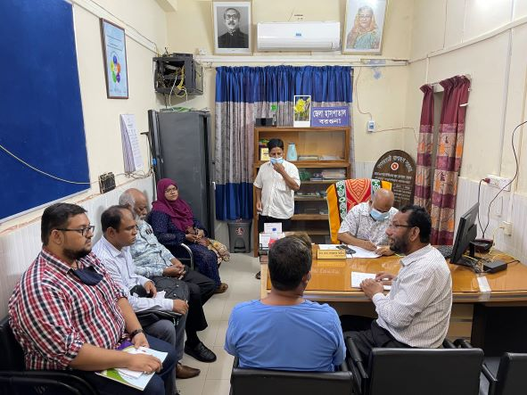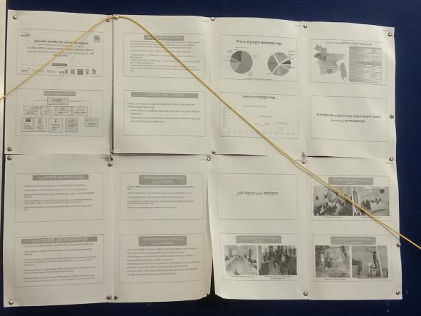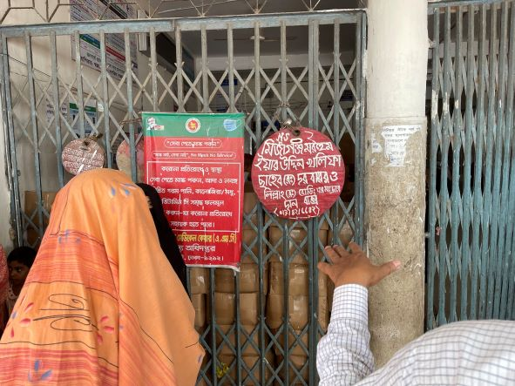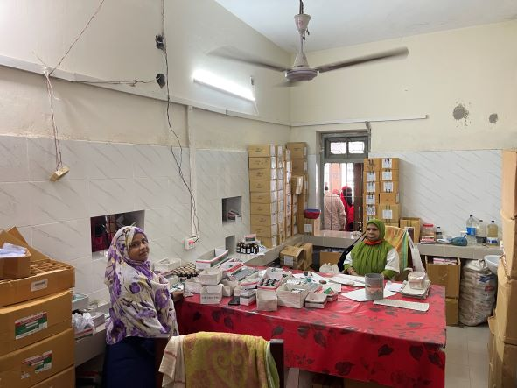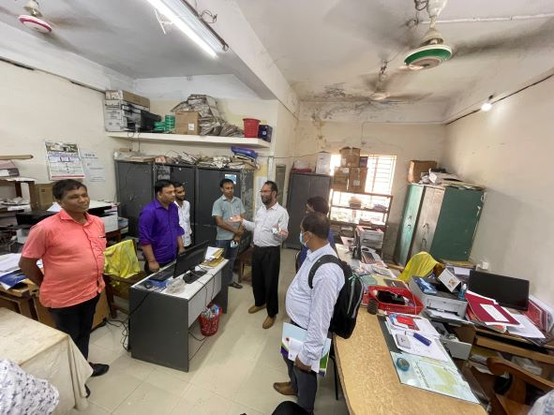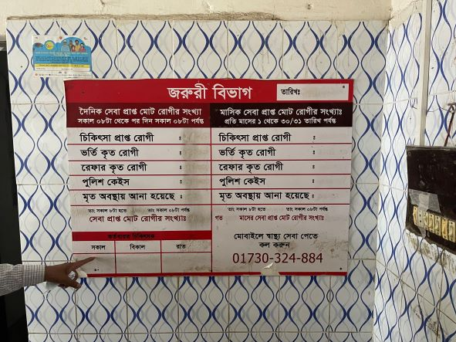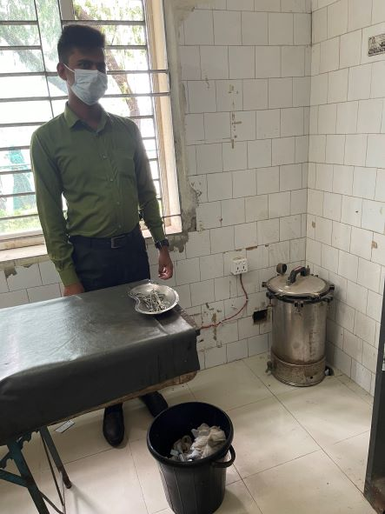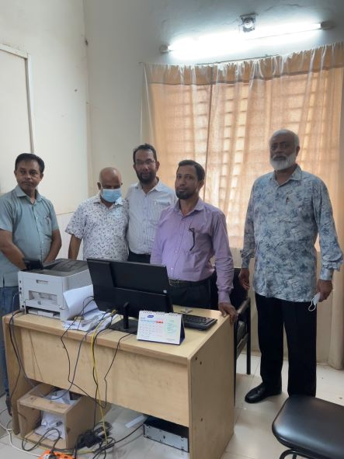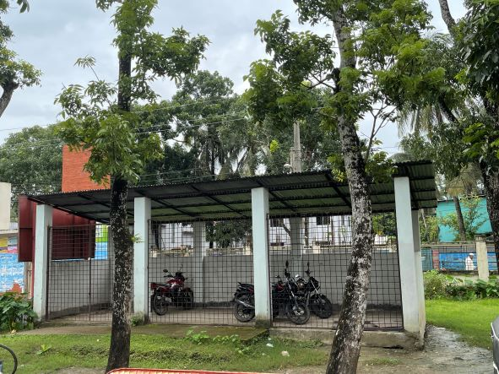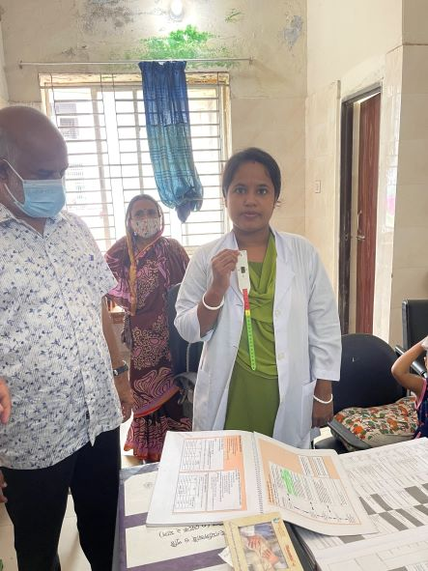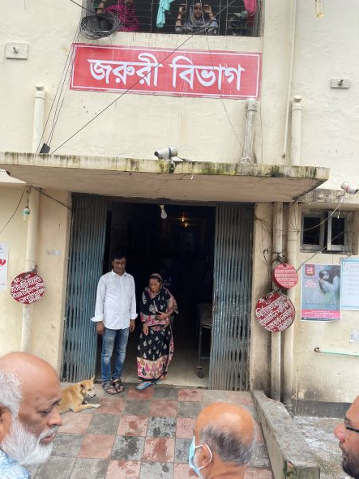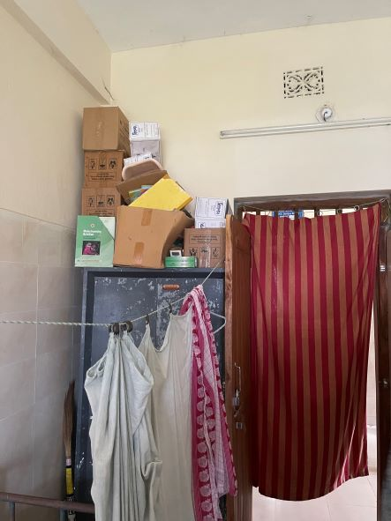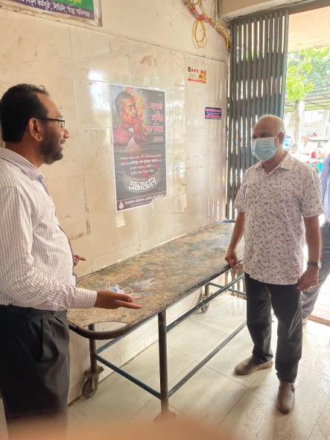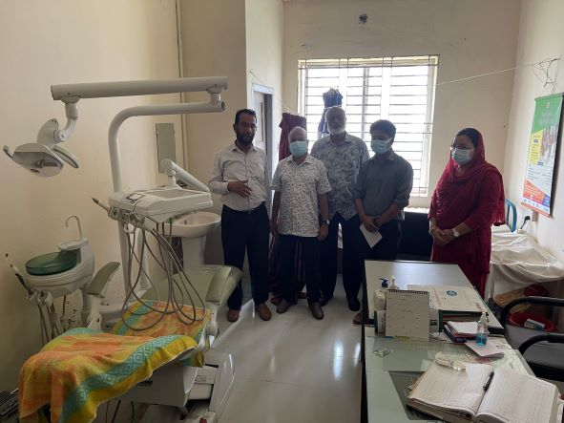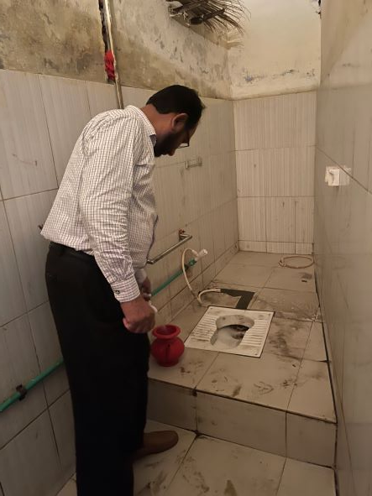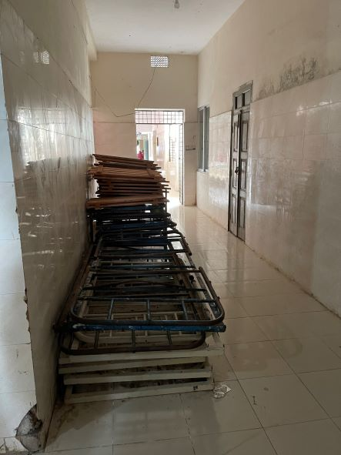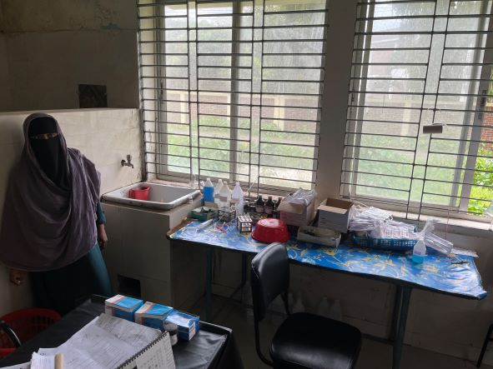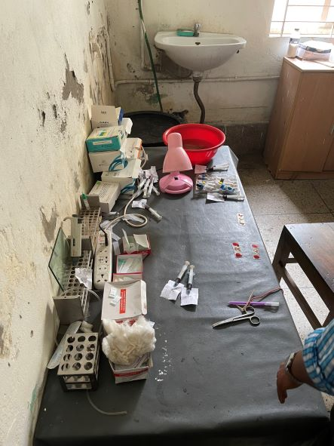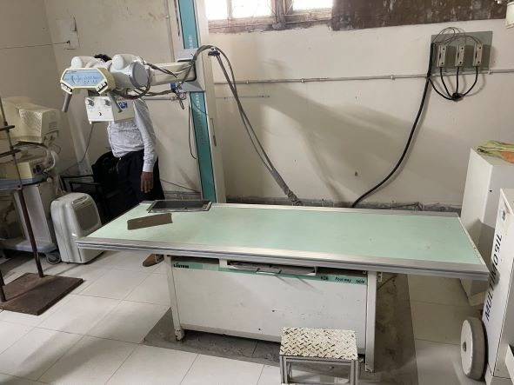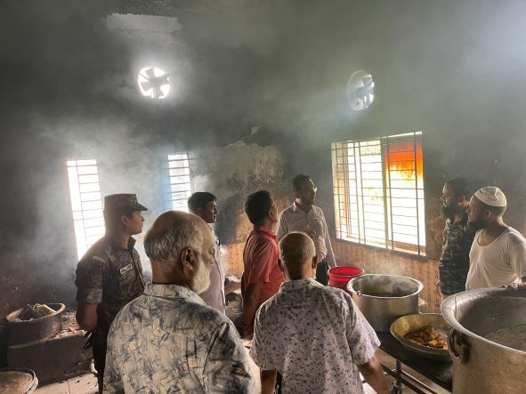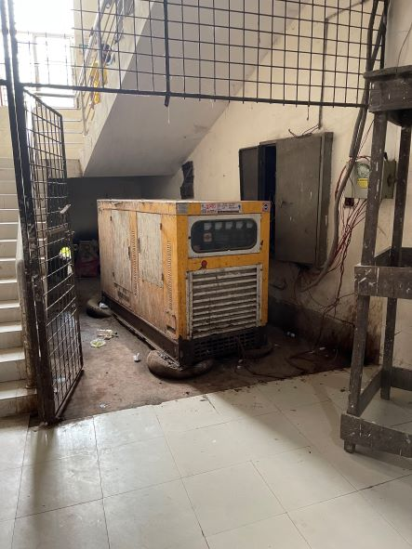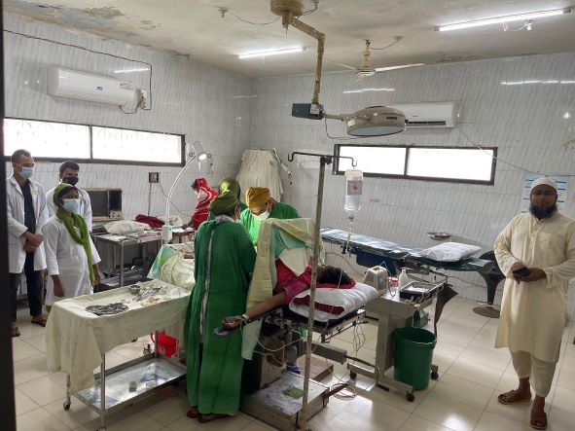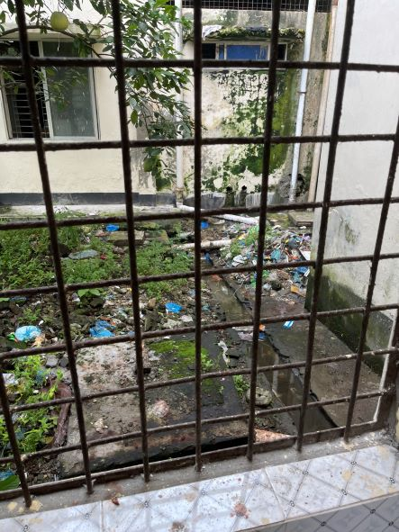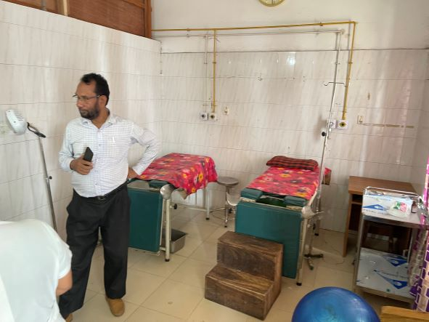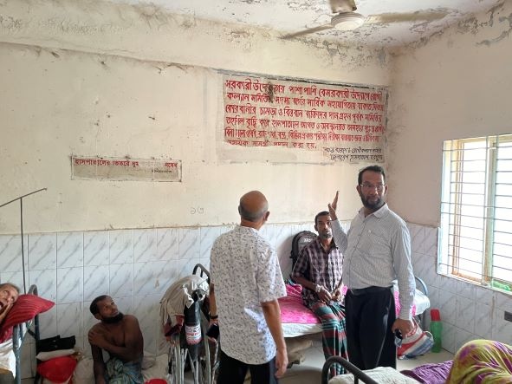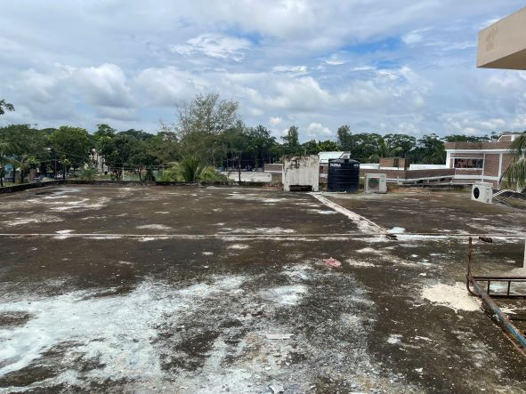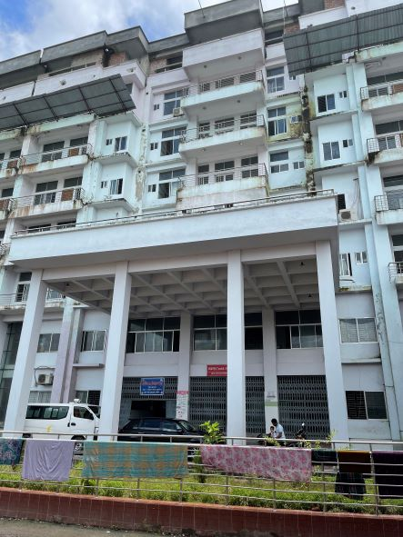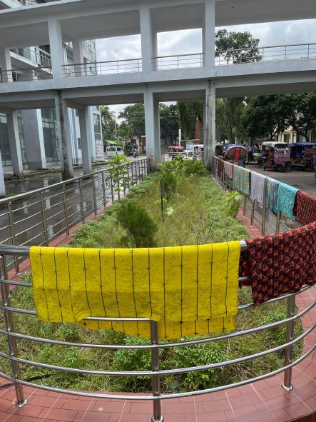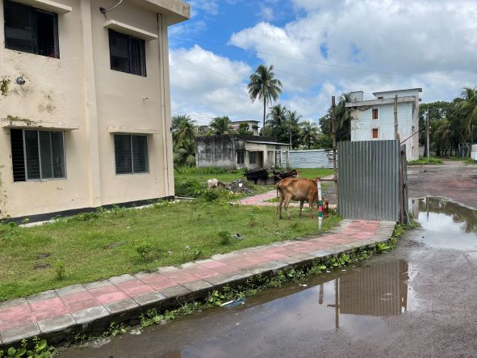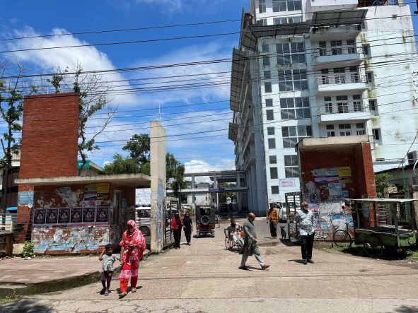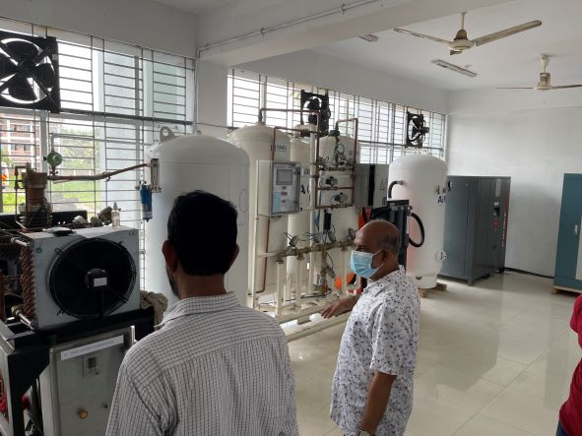
Fig-1: Discussion with Superintendent, RMO and Junior Consultants
Fig-1: Discussion with Superintendent, RMO and Junior Consultants
Fig-2: Display board of Superintendent office
Fig-3: Lots of Danbox throughout the hospital premises
Fig-4: Pharmacy room, not organized
Fig-5: Office room; Files and papers are not organized
Fig-6: Display board in the emergency room (Good Practice)
Fig-8: Nonfunctional Sterilizer machine
Fig-9: Automation system in the office room
Fig-10: Cycle stand in front of corridor
Fig-11:
Fig-12: Danbox at the entrance of Emergency dept.
Fig-13: Unwanted items above the Almira of emergency room
Fig-14: Trolley at emergency gate
Fig-15: Dental unit
Fig-15: Unclean toilet of indoor
Fig-15: Unclean toilet of indoor
Fig-15: Unwanted items in hospital corridor
Fig-17: disorganized items in Pathology room
Fig-18: Pathological procedure ongoing
Fig-19: X-ray facility in the hospital
Fig-20: Nonfunctional exhaust fan in the kitchen
Fig-21: Nonfunctional generator
Fig-22: OT room
Fig-23: unclean backside of the hospital
Fig-24: Labour room
Fig-25:
Fig-26: Clean and beautiful roof of the hospital
Fig-27: New hospital building
Fig-28: Unclean garden in front of the hospital building
Fig-29: Back side area of the hospital
Fig-30: Entrance of the hospital building, no gate was there
Fig-31: Oxygen generation plant for oxygen support for the hospital

